**Communications Preparedness Planning Template**

Every farm with livestock should have a communications preparedness plan and a response team in place for unanticipated issues that might arise. Just like an emergency plan for a tornado or a fire, there should be a preparedness plan for situations that center on your animals.

This template will help you develop a preparedness plan for your own operation. “Be prepared for anything,” make sure you have Standard Operating Procedures (SOPs) in place and train your employees on the plan. This will make it easier to manage the details in the event an unanticipated situation occurs. It will also help minimize the impact of the situation on the dairy and livestock industries.

**Things to consider as you put together a preparedness plan:**

* Do you have an existing emergency plan that could be enhanced to include animal well-being situations?
* When will you implement the plan? What will you consider an “emergency?”
* Who will be in charge if something happens?
* Who should be on your response team?
* In case of an emergency…how will you notify the team? Where will you meet?
* Who is responsible for what?
* Who is authorized to speak? Is your spokesperson media trained?
* How will you communicate with your employees? Your customers? Your processor? Your milk hauler?
* Do you have a key contact list with phone numbers, addresses and email contact information?
* Do you have any messaging that is already created for your farm or operation?

**PREPAREDNESS STEPS**

* **Identify your core response team and spokesperson**

Determine in advance who on your team is authorized to speak – and who isn’t – and, specifically, what roles each will play in the event of an unexpected situation. Your media spokesperson should be media trained and, if the spokesperson isn’t you, it should be someone you trust to represent your farm.

* **Assemble a key contact list with emergency numbers**

Think through who you might need to contact in the event of a crisis. Put all of those names and phone numbers in one place that is easily accessible. This will save valuable time in the heat of the moment.

* **Draft your communications preparedness plan**

A communications preparedness plan developed in advance will include a response flow chart that outlines – at a glance – how the issue will be handled and communicated about. It provides the structure you need to coordinate a response including:

* A “call tree”
* Plan to secure your property
* How you will communicate with employees, key stakeholders and the media
* Key messages about your farm
* **Train your employees on the plan**

Make sure they know who to call if they suspect an issue, who will be communicating with them and who the designated person will be communicating externally on behalf of the farm.

* **Attend crisis communication media training**

Proactive media training for key members of your farm’s core response team is strongly recommended.

**Identify your core response team and responsibilities of each member:**

These are the first individuals you will call and those who will be in charge in the case of a fire, tornado, manure spill, on-farm accident or an animal care issue. Your core response team should include you, of course, along with key family members, your attorney, your veterinarian, herdsman or perhaps other on-farm specialists such as your nutritionist. A communications expert should also be part of your core response team as he/she will help you develop appropriate messaging and handle calls from the media and authorities. The chart below will begin to help you think about the flow of communication and who should be part of your core response team.

|  |  |  |  |  |  |
| --- | --- | --- | --- | --- | --- |
| **Core Response Team** | **Name** | **Work phone number** | **Cell phone number** | **Home phone number** | **Email address** |
| Key decision maker |  |  |  |  |  |
| Trained media spokesperson |  |  |  |  |  |
| Trusted family member |  |  |  |  |  |
| Attorney |  |  |  |  |  |
| Communications professional |  |  |  |  |  |
| Veterinarian |  |  |  |  |  |
| Herdsman |  |  |  |  |  |
| Nutritionist |  |  |  |  |  |
| Employee liaison |  |  |  |  |  |
| Customer/supplier liaison |  |  |  |  |  |
| Informs key stakeholders |  |  |  |  |  |
| Secures property |  |  |  |  |  |
| Updates website and social media |  |  |  |  |  |
| Monitors traditional and social media |  |  |  |  |  |
| Monitors calls/maintains phone logs; ensures flow of information |  |  |  |  |  |
| Other |  |  |  |  |  |
| Other |  |  |  |  |  |
| Other |  |  |  |  |  |

**Now, repeat this exercise, and identify back-up members for each team member in the event that they are unavailable at the time of an incident:**

|  |  |  |  |  |  |
| --- | --- | --- | --- | --- | --- |
| **Core Response Team** | **Name** | **Work phone number** | **Cell phone number** | **Home phone number** | **Email address** |
| Key decision maker |  |  |  |  |  |
| Trained media spokesperson |  |  |  |  |  |
| Trusted family member |  |  |  |  |  |
| Attorney |  |  |  |  |  |
| Communications professional |  |  |  |  |  |
| Veterinarian |  |  |  |  |  |
| Herdsman |  |  |  |  |  |
| Nutritionist |  |  |  |  |  |
| Employee liaison |  |  |  |  |  |
| Customer/supplier liaison |  |  |  |  |  |
| Informs key stakeholders |  |  |  |  |  |
| Secures property |  |  |  |  |  |
| Updates website and social media |  |  |  |  |  |
| Monitors traditional and social media |  |  |  |  |  |
| Monitors calls/maintains phone logs; ensures flow of information |  |  |  |  |  |
| Other |  |  |  |  |  |
| Other |  |  |  |  |  |
| Other |  |  |  |  |  |

**Assemble key contact lists and emergency numbers in one place that is easily accessible in the heat of the moment.**

|  |  |  |  |  |
| --- | --- | --- | --- | --- |
| **Emergency phone numbers**  **(outside of 911)** | **Phone numbers** | | | **Email address** |
| Fire Department |  | | |  |
| Local Police Department |  | | |  |
| State Police Department |  | | |  |
| County Sheriff |  | | |  |
| Local Hospital(s) |  | | |  |
| Family Doctor |  | | |  |
| Gas/Power Company |  | | |  |
| Other |  | | |  |
| **Key Contacts** | **Phone numbers (work/cell)** | | | **Email address** |
| Processor/Plant/Co-op Representative |  | | |  |
| Processor/Plant/Co-op Communications Liaison |  | | |  |
| Milk Hauler/Shipper |  | | |  |
| Cull Cow Customer/s |  | | |  |
| Equipment Dealer/Mechanic |  | | |  |
| Ag Chemical Dealer |  | | |  |
| Key Customers |  | | |  |
| Suppliers |  | | |  |
| Other |  | | |  |
| **Other Allied Third-Party Resources** | **Phone numbers (work/cell)** | | | **Email address** |
| State Department of Agriculture |  | | |  |
| Industry Associations |  | | |  |
| Dairy Organization Liaison |  | | |  |
| University Expert |  | | |  |
| County Extension Consultant |  | | |  |
| Livestock Association Liaison |  | | |  |
| Other |  | | |  |
| **Regulatory Agency Representatives** | **Phone numbers (work & cell)** | | **Email address** | |
| USDA |  | |  | |
| FDA |  | |  | |
| EPA |  | |  | |
| OSHA |  | |  | |
| DNR |  | |  | |
| ICE |  | |  | |
| Other |  | |  | |
| Other |  | |  | |
| **Media Outlets** | **Phone numbers (work & cell)** | **Email address** | | |
| **Daily Newspapers** |  |  | | |
|  |  |  | | |
|  |  |  | | |
|  |  |  | | |
| **Weekly Newspapers** |  |  | | |
|  |  |  | | |
|  |  |  | | |
| **Radio Stations** |  |  | | |
|  |  |  | | |
|  |  |  | | |
|  |  |  | | |
| **TV Stations** |  |  | | |
|  |  |  | | |
|  |  |  | | |
|  |  |  | | |
| **Trade Publications** |  |  | | |
|  |  |  | | |
|  |  |  | | |
|  |  |  | | |
|  |  |  | | |
| **Family, Local and**  **Other Important Contacts** |  |  | | |
| **Extended Family** |  |  | | |
|  |  |  | | |
|  |  |  | | |
|  |  |  | | |
|  |  |  | | |
| **Local Neighbors** |  |  | | |
|  |  |  | | |
|  |  |  | | |
|  |  |  | | |
|  |  |  | | |
| **Trusted Friends** |  |  | | |
|  |  |  | | |
|  |  |  | | |
|  |  |  | | |
|  |  |  | | |
|  |  |  | | |

**DRAFT YOUR COMMUNICATIONS PREPAREDNESS PLAN**

The first step in developing a communications preparedness plan is identifying potential issues that would create a problem on your farm/operation.

**Determine what should be considered a crisis, which is any situation that:**

* You don’t expect
* You don’t have all the facts about
* Could escalate
* Interrupts your operation
* Affects your bottom line
* Concerns your reputation
* Impacts your industry

**These situations could include:**

* Natural disasters
* Environmental emergencies
* Destruction to property
* Injury to persons on your farm
* Animal welfare situations

**Identifying Potential Issues**

List the situations that you would consider a crisis on your farm or operation to enable you to think through how you would handle them. You should be able to easily identify those situations that would require immediate response – in advance. Take this thought process to the next step. Who will take the lead in a response effort for each? Who will be the best spokesperson in each situation? What are the messages?

*(Add additional sheets as necessary.)*

|  |  |
| --- | --- |
| **Issue** | **Response Team Leader** |
|  |  |
|  |  |
|  |  |
|  |  |
|  |  |
| **Spokesperson:** | **Messages** |
|  |  |
|  |  |
|  |  |
|  |  |
|  |  |
|  |  |
|  |  |
|  |  |
|  |  |
|  |  |
| **Spokesperson** | **Messages** |
|  |  |
|  |  |
|  |  |
|  |  |
|  |  |
|  |  |
|  |  |
|  |  |
|  |  |
| **Spokesperson** | **Messages** |
|  |  |
|  |  |
|  |  |
|  |  |
|  |  |

**Develop a Communications Flow Chart**

**Before there is a crisis, determine the flow of events beginning at the time you are notified of an incident.**

How will you notify your response team? What happens next? Every step should be outlined, including determining whether or not there really is a crisis.

A sample communications flow chart might look something like this:

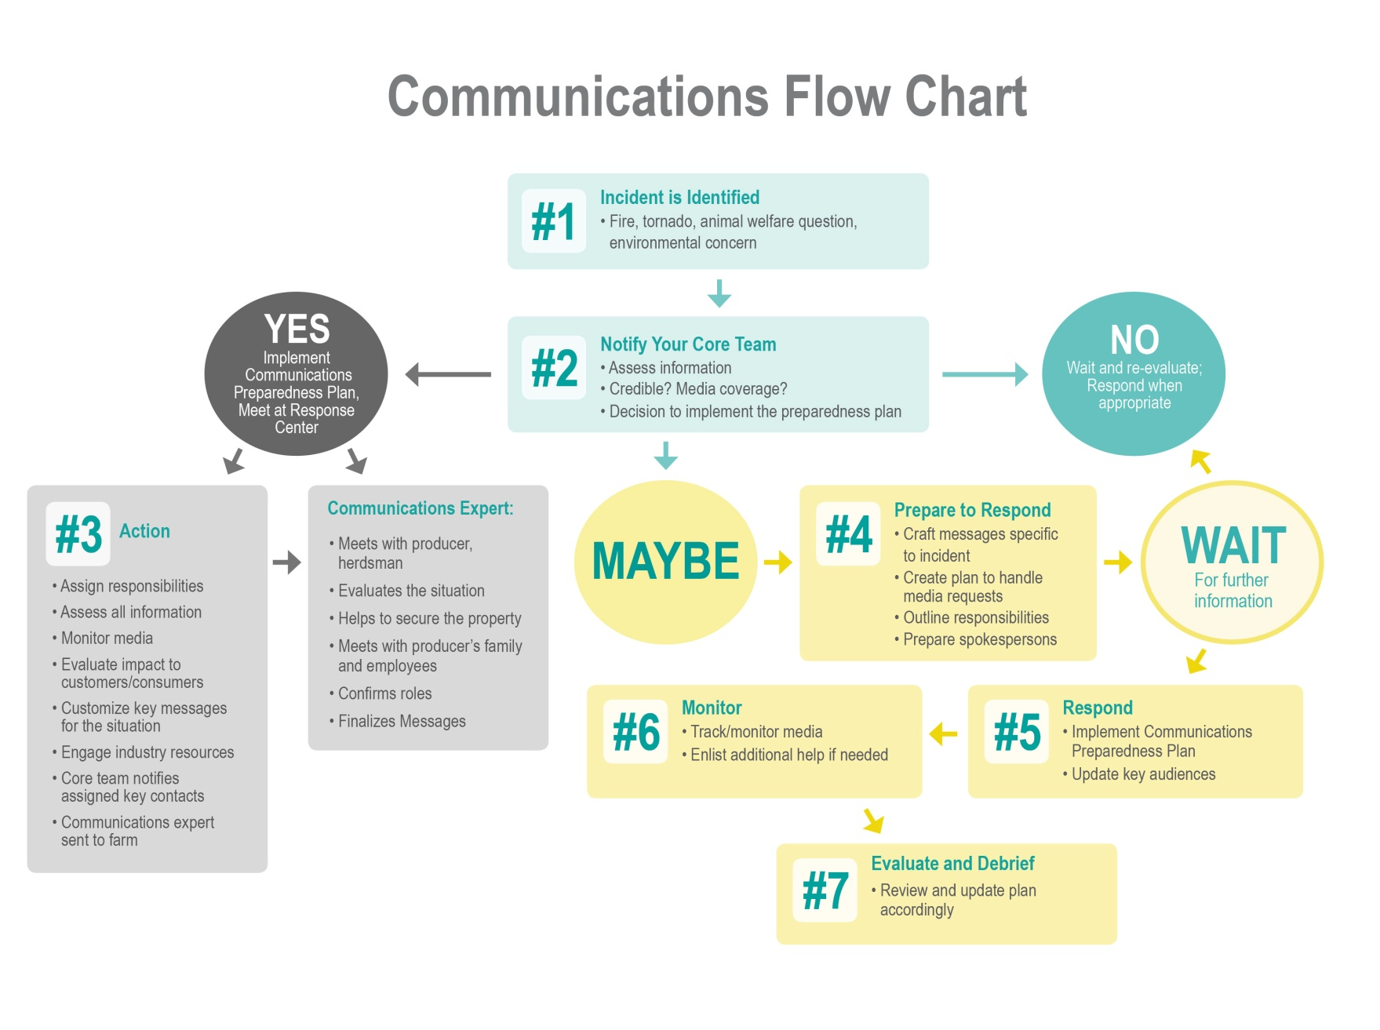

**Putting the Communications Flow Chart Into Action**

**Notifying the team – creating a call tree:**

Now that you have identified your response team, how will you notify the team when there is a potential issue? Where will you meet to discuss next steps? Constructing a call tree will help everyone get the word out quickly.

**CALLS**

**1-844-MAH-CARE**

**AND**

**ASSEMBLES THE RESPONSE TEAM**

**First to be notified: Response Team**

**Leader: name & contact information**

NAME

NAME

NAME

NAME

NAME

NAME

NAME

NAME

NAME

**Assembling the Core Response Team and Assigning Responsibilities**

This gets at the heart of the matter – deciding in advance how your core team will operate, who will be responsible for what, how you will keep key stakeholders informed and how you will handle the media. You decided earlier in this exercise who would be responsible for handling specific tasks while you are managing an issue. Here are some other things to consider:

* **Where will you meet?** The meeting place should be on-farm, but away from the media spotlight.
* **Is there a conference call-in number** and passcode available? **Your attorney and others may not immediately be able to be at your farm, so your core team may need to call in from different locations.**
* **Do you have an 800 number that you can use** to handle calls from customers, suppliers and other interested parties seeking information?
* **If you grant media interviews, where will they be conducted?** Be careful to conduct interviews in a place that shows your farm in a positive light.
* **Determine key audiences/stakeholders who should be contacted and kept in the loop** and make sure they are on your key contact list.

|  |  |
| --- | --- |
| Response team meeting place |  |
| Conference call-in number |  |
| 800 Number |  |
| Who will evaluate the impact on the cooperative/processor/customers & consumers? |  |
| Who will review/update key messages? |  |
| Does your farm/operation have a website where you can post information? Who is responsible for that? Are you active in social media? If so, can you disseminate information via Facebook or Twitter? Who will do that? |  |

**Consider in advance, how you will manage media requests. Outline your plan for communicating with the media to the extent that you can, in advance.**

* How will you respond to media requests?
* Will you grant interviews?
* Where will you conduct interviews? On the farm? Where? When? On the phone?
* Who is responsible for facilitating interviews?
* Will you consider a press conference?
* Will you issue statements or a news release?
* How will you distribute these materials? Email? Wire service? Fax?

**Plan to Secure Your Property**

Consider your property. Is it fenced? Can anyone gain access to the farm/operation, barns, milking parlor? How will you secure your property to protect yourselves and your animals? In addition to notifying local law enforcement, consider posting “no trespassing” signs at the entrance to your property. Think through how you might reduce or eliminate access. Consider assigning a family member to serve as the sentry to allow access to those who should be on the farm and deny access to those who shouldn’t.

Use the diagram below to help you visualize your property and access points. Indicate buildings, the road and access points onto the property.

**Knowing What You Will Say…Before You Need to Say It**

**Prepare key messages about your farm in ADVANCE.**

You probably have some basic key messages that you have already developed about your farm/operation. If not, prepare them in advance, so they are readily available. They should include:

* Your mission – Why you are in business – what your goals are for your farm/operation. ________________________________________________________________________________________________________________________________________________________________________
* Your history – How long you have been in operation with some interesting anecdotes that tell the story of who you are or stories about your family on the farm.

________________________________________________________________________________________________________________________________________________________________________

* Your vision – Your aspirations for your farm/operation – what you want your farm to be. ________________________________________________________________________________________________________________________________________________________________________
* Your values – How you expect your farm to be run, your animals to be treated, and your employees to act. This could be your animal care commitment.

________________________________________________________________________________________________________________________________________________________________________

**A fact sheet about your farm/operation can also be developed that includes:**

* Farm basics – farm name, crops, livestock, acreage
* Farm employees – Who runs it, how many employees, how many families does it support?
* Management practices – Animal handling, health and care protocols
* Other management practices – Robotics, precision ag, rotational grazing, etc.
* Environmental/sustainability efforts – Conservation tillage, buffers, manure management, etc.
* Farm history – Who started the farm? How many generations has it been in your family?
* Farm philosophy – Why do you do what you do? What you love about farming?
* Extracurriculars – What organizations are you active in? Ag, dairy, civic, church, etc.
* Anything else you want people to know about your farm – Will your children take it over? Are you planning to expand? What are you most proud of?

**You can also prepare key messages for a crisis situation in advance, so that you need only to fill in the particulars in the event that an issue emerges. In the event of an animal abuse video, key messages must include a statement that:**

* **Acknowledges the problem.** “For more than 25 years, we’ve trained our employees to live up to our expectations of animal care. This behavior is not acceptable, and we do not condone it. It’s not aligned with our expectations for animal care. Our animal care commitment reinforces our expectations for how we expect our animals to be cared for.”

____________________________________________________________________________________

____________________________________________________________________________________

* **Takes full responsibility and explains the steps you are taking.** “We’ve suspended/fired X employees and have hired an independent animal welfare auditing firm to investigate our farm and review all animal care and handling procedures.”

____________________________________________________________________________________

____________________________________________________________________________________

* **Explains that you’re cooperating fully with authorities.** “We’re working with the County Sheriff on a full investigation.”

____________________________________________________________________________________

____________________________________________________________________________________

* **Shows your commitment to animal well-being on your farm.** “We have an animal care commitment and SOPs in place to help ensure these situations don’t happen. This is an isolated incident, and we are taking action to ensure this doesn’t happen again.”
* **Demonstrates your determination to move beyond this situation.** “We’ll get to the bottom of this and take the appropriate steps to make sure this never happens again.”

____________________________________________________________________________________

____________________________________________________________________________________

**Prepare Q&A in anticipation of media questions:**

* How could you not know?
* How could this happen?
* How long has this been going on?
* Have the employees been fired?
* Don’t you train employees?
* Have you checked out the other animals? Have they been abused?
* How can we trust you?
* Why should we trust you?
* How do we know this won’t happen again?
* Why should you still be allowed to raise animals?
* Why shouldn’t you be held responsible for what happens on your farm?

**Train Your Employees on the Plan**

Make sure your employees know who they should call in the event they see any actions that are not aligned with your expectations or that a potential unacceptable situation is emerging. They should call the Response Team Leader or their immediate supervisor. Ensure they have the Response Team Leader’s contact information – post it in the barn or in a visible place on your operation – and that they know when to use that phone number. Let them know they should not be afraid to call – better safe than sorry.

It is also a good idea to conduct a “mock crisis.” This gives everyone the opportunity to “practice” in advance. It also gives you an idea of where you might need to make adjustments to your plan and procedures.

**Media train your spokesperson:**

It would be difficult for anyone to experience a media interview for the first time in the heat of a crisis. Media training can be invaluable to help a spokesperson calmly and credibly deliver information to your audience. Media training can help the spokesperson take control of an interview, satisfy reporter questions and most importantly deliver your key messages.

*A note of thanks: This resource is based in part on earlier efforts of several organizations, including Dairy Management Inc., United Dairy Industry Association, Professional Dairy Producers of Wisconsin, Cooperative Extension and the United States Department of Agriculture.*